**Project Deployment**

**Summary:**

The entire code of implementation has been completed and deployed in the GitHub. The GitHub link is provided below:

* <https://github.com/sk7x9/CS551-Project>

The project description and methodologies are described briefly and pictured as a video. This video has been uploaded to the YouTube which can be viewed using the following link:

* <https://www.youtube.com/watch?v=xr1KYSDQMZc&feature=youtu.be>

**User Manual**

**System Requirements:**

Operating System: Android

Android Version Support: Froy to Jellybean

Memory required: 256MB

Internet Connection: Yes

Devices: Android mobile with GPS

**Goal:**

With the increase in technology and globalization data is increasing day by day. Gathering required information from these huge volumes of available data is really difficult. Let us consider a scenario where a job seeker wants to search for a job based on his profile, requirements, income and location.

Our main objective is to design a native mobile application that makes the job search process easier for the job seeker. Finding the exact job is really difficult based on the available pool. So we employed specific criteria to make it easy, we are planning to include country codes, Zip codes for searching the available positions with various employers.

**Guide Lines:**

1. Please download the JobAmigo.apk file and install it onto your mobile device.
2. Once you have installed the application, Launch the application by clicking or tapping JobAmigo icon which will be displayed on your screen.
3. Now you can see the home page of the application and a welcome button.
4. Click on the welcome button then you will be redirected to the login screen where there are options to register and sign in.
5. There are validations and text to speech conversion for all the buttons present in the UI.
6. Once the user is registered after the successful authentication he will be directed to the page with the 5 application features present.
7. Click on the first button Search by country which directs to next page which has a text box and search button for searching the jobs using country codes.
8. After clicking on the search button the results of particular location are retrieved.
9. It has a go to website button where we can directly go to the company website and apply for a position.
10. You will get an SMS alert on the registered mobile number saying that you are applying to the position using JobAmigo.
11. Then click on the second button Route finder which finds the destination to the required places in the search.
12. Later click on the Weather finder which will redirects to a page where we can find the weather of particular location and climate report for the next 4 days.
13. Click on the fourth button called as QR & Instagram features which generates a QR-Code when we enter some data in the blank text box and we can scan it with the QR scanner and find the originality of the QR code.
14. Next coming to the Instagram where we can share the images from various sources to the social networking sites or to friends.
15. Now click on the last button called as Resume service by which we can complete our resume profile and submit it to the portal.
16. After submitting this is the final phase of our project where the job search ends.

**Sample Execution:**

**Implementation of User Interface:**

The entire implementation of the UI is shown on an Android device which is flexible for the Android user. As emulator loading is time consuming. The whole process is clearly documented below n the form of screen shots and explained clearly.

The screen shots are arranged in a sequence manner of operations based on the services used in the application.

**Documentation:**

**Screen Shots of Home page, Login and Sign up with authentications and validations using the services hosted on the UMKC Server:**

 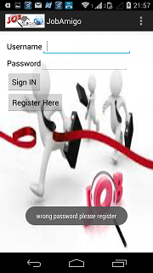 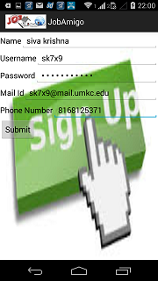

**Screen Shots of existing Job Search API and Implementation and Receive SMS Alerts when Applied for a particular position in a company:**

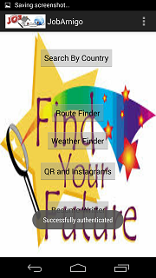  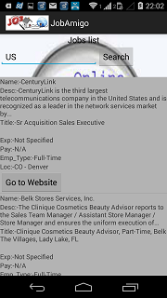

**Screen Shots of Google Map Services used for finding the Routes for the user**

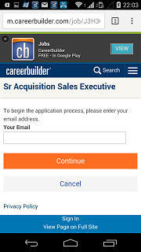 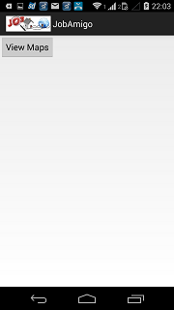 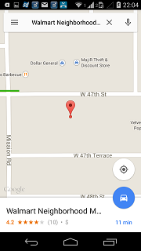

**Screen Shots of Weather Services used for Weather prediction of a location**

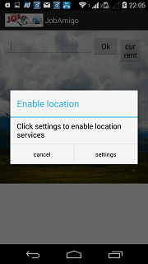 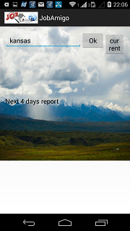 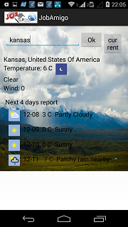

**Screen Shots of QR & Instagram Functionalities for Picture Sharing and Scanning**

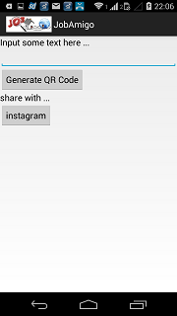 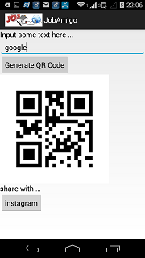 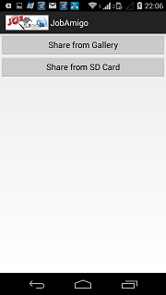

**Sharing from the required place to the friends and networks**

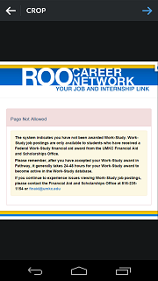 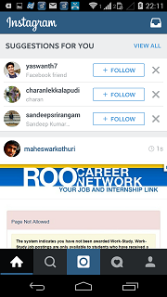

**Screen Shot of Resume Services hosted in UMKC Server and final phase of resume submission**

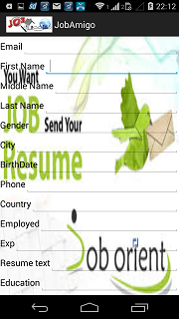 

This is the final page of the application which says that the job search for a particular user will end finally after selecting to the applied position.

**Troubleshooting:**

* If you have any issues while installing, please remove the apk and reload it.
* If it takes lot of time for the search results to display please refresh the page and in case if you are a registered user please logout and login again.
* If recommended results are vague after you click search button, make sure to check whether your user profile details are accurate or not.

**Note:**

The project idea has been incorporated from Big Apps NYC 2014

<http://bigapps2014.splashthat.com/>

We have used some existing API’S and some new services.

We used career builder API for the job results and parsed the results.

<http://api.careerbuilder.com/Search/jobsearch/jobsearchinfo.aspx>